***PAAREES PERFUMES***

***VERSACE***

***FOR UNISEX***

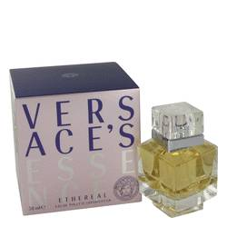

# 

# *Versace Essence Etheral*

## *Description:*

Versace Essence Etheral by Versace Perfume. Versace Essence Etheral is a sexy and refreshing fragrance for vibrant women. Introduced by Versace in the year 2000, the fragrance is incredibly light. A daytime fragrance, Versace Essence Etheral features an intoxicating mixture notes. Extremely feminine, the scent blends together tones of peach and wisteria with mimose, jasmine and base notes of violet. Spritz on Versace Essence Etheral any time you need to brighten up. It is the ideal casual scent to liven up summer days.